**Name:- Dharan Gowda Superset id:-6387532**

**Creating Microservices for account and loan**

**I ) creating account section**

**Step1:-Setup Project Folder**

**Step2:-Create the Account Microservice**

**2.1 Generate Spring Boot Project**

**2.2 Build the Project**

**2.3 Import in Eclipse**

**2.4 set the port :- server.port=7080 in application.properties**

**Step3:-** **Create Controller for Account**

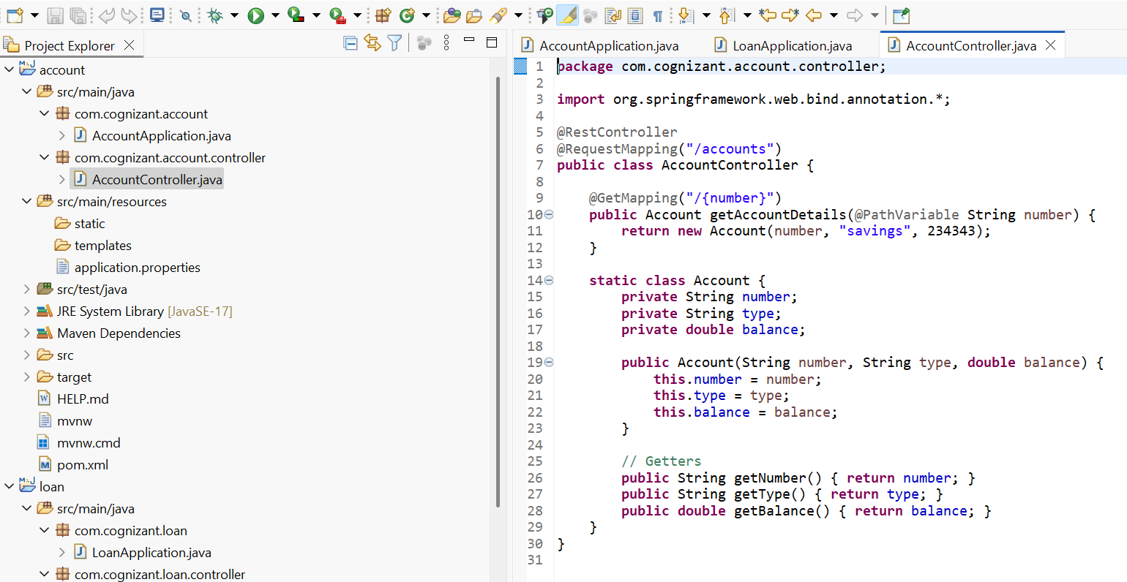

**Step 4:- Run & Test Account Microservice**

**Run :- AccountApplication.java**

**Output :- At console**

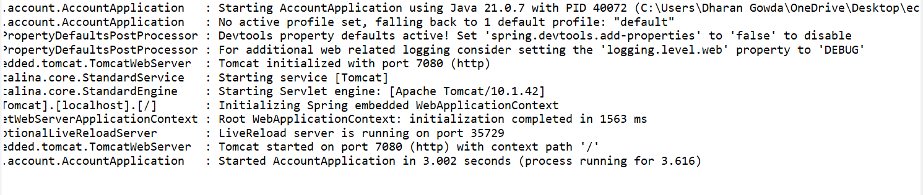

**At browser :- running at port 7080**

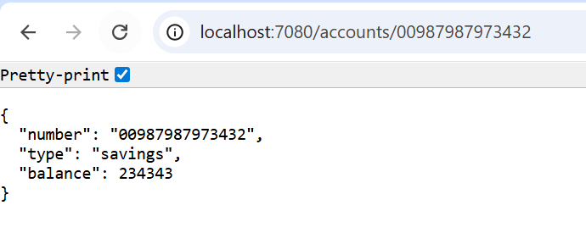

**II) Creating Loan section**

**Step1:-Setup Project Folder**

**Step2:-Create the Loan Microservice**

**2.1 Generate Spring Boot Project**

**2.2 Build the Project**

**2.3 Import in Eclipse**

**2.4 set the port :- server.port=7081 in application.properties**

**Step 3) Create Controller for Loan**

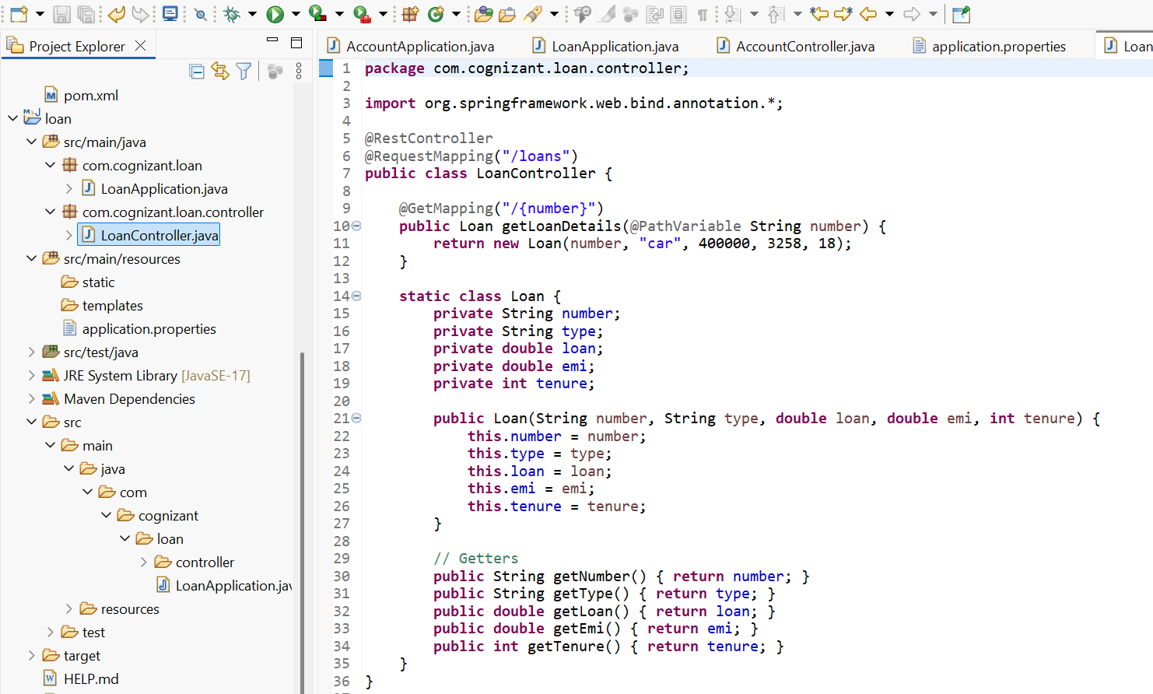

**Step 4:- Run & Test Loan Microservice**

**Run :- LoanApplication.java**

**Output :- At console**

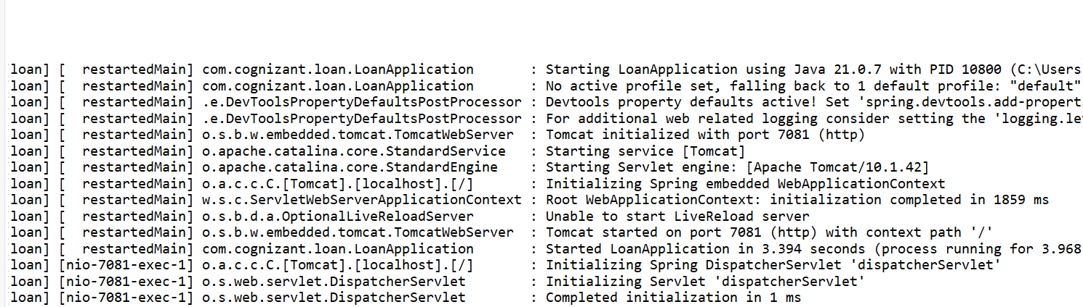

**At browser :- running at port 7081**

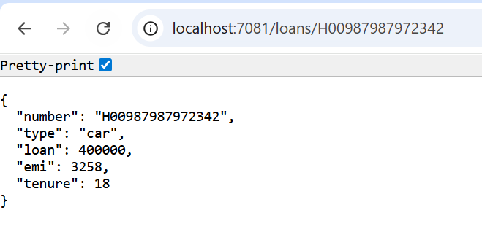

**Now we have implemented two independent Spring Boot microservices as part of a hands-on banking exercise:**

1. **Account Microservice:**
   * **Runs on port 7080**
   * **Endpoint: GET /accounts/{number}**
   * **Returns dummy account details in JSON format**
2. **Loan Microservice:**
   * **Runs on port 7081 (customized from default 8081)**
   * **Endpoint: GET /loans/{number}**
   * **Returns dummy loan details in JSON format**